- 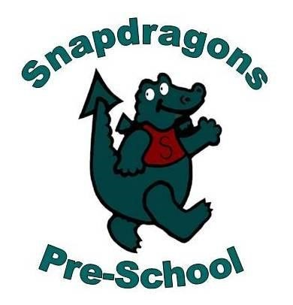Policy and procedures implementation and review policy

Alongside associated procedures in 0.0 Implementation and review, this policy was adopted by Snapdragons Pre School on 17.01.2022.

Aim
We have one set of policies and procedures which are consistent across our childcare provision and in line with the current EYFS requirements.
Objectives
We adhere to and implement operational policies and procedures by:
- ensuring that all members of staff are aware of their role and responsibility in policy and procedure implementation
- ensuring that members of staff are aware of the content of the policies and procedures through:
- induction
- line management and staff meetings and training events
- contributing feedback to procedure review
- use of relevant publications
- Staff are aware of their duty to adhere to the operational policies and procedures and how they contribute to a consistent approach throughout the organisation.
Legal references
Childcare Act (2006)
Education Act (2011)

