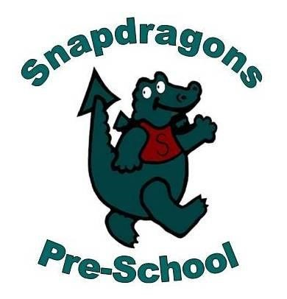01 Standard Health and Safety Procedures
01.14 Control of Substances Hazardous to Health (COSHH)
- Staff implement the current guidelines of the Control of Substances Hazardous to Health (COSHH) Regulations.
- Personal protective equipment (PPE), such as rubber gloves, latex free/vinyl gloves, aprons etc., is available to all staff as needed and stocks are regularly replenished.
- Hazardous substances are stored safely away from the children.
- Chemicals used in the setting should be kept to the minimum to ensure health and hygiene is maintained.
- Risk assessment is done for all chemicals used in the setting.
- Environmental factors are considered when purchasing, using and disposing of chemicals.
- All members of staff are vigilant and use chemicals safely.
- Bleach is not used in the setting.
- Anti-bacterial soap/hand wash is not normally used, unless specifically advised during an infection outbreak, such as Pandemic flu or Coronavirus.
- Anti-bacterial cleaning agents are restricted to toilets, nappy changing areas and food preparation areas and are not used when children are nearby.

