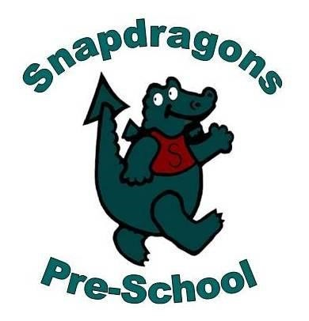06 Safeguarding children, young people and vulnerable adults procedures
6.10 Key person supervision
Staff taking on the role of key person must have supervision meetings in line with this procedure.
Structure
- Supervision meetings are held every 4-6 weeks for key persons. For part-time staff this may be less frequent but at least every 6-8 weeks
- Key persons are supervised by the setting manager or deputy.
- Supervision meetings are held in a confidential space suitable for the task
- Key persons should prepare for supervision by having the relevant information to hand.
Content
The child focused element of supervision meetings must include discussion about:
- the development and well-being of the supervisee’s key children and offer staff opportunity to raise concerns in relation to any child attending. Safeguarding concerns must always reported to the designated person immediately and not delayed until a scheduled supervision meeting
- reflection on the journey a child is making and potential well-being or safeguarding concerns for the children they have key responsibility for
- promoting the interests of children.
- coaching to improve professional effectiveness based on a review of observed practice/teaching
- reviewing plans and agreements from previous supervisions including any identified learning needs for the member of staff
- During supervision staff can discuss any concerns they have about inappropriate behaviour displayed by colleagues, but must never delay until a scheduled supervision to raise concerns.
- Staff are reminded of the need to disclose any convictions, cautions, court orders, reprimands and warnings which may affect their suitability to work with children that have occurred during their employment. New information is referred immediately to the designated officer.
Recording
- Key person supervision discussions are recorded and is retained by the supervisor and a copy provided to the key person.
- The key person and supervisor must sign and date the minutes of supervision within 4-6 weeks of it happening and disagreements over recorded content must be minuted.
- Each member of staff has a supervision file that is stored securely at all times.
- Concerns raised during supervision about an individual child’s welfare may result in safeguarding concerns not previously recognised as such, these are recorded on 06.1b Safeguarding incident reporting form and placed on the child’s file. The reasons why the concerns have not previously been considered are explored.
- Additional safeguarding or welfare decisions made in relation to a child during supervision are recorded on the individual case file. The supervisor (if not the designated person) should ensure the recording is made and the designated person is notified.
Checking continuing suitability
- Supervisors check with staff if there is any new information pertaining to their suitability to work with children. This only needs to be recorded on the supervision meeting record.
- Where staff are on zero hours contracts or are employed as and when needed, their line manager completes the staff suitability self-declaration form quarterly, and/or at the beginning of every new period of work.
- Regarding the use of agency staff/support workers/self-employed persons there is an expectation that as part of the agreement with agencies they have sought information regarding their employee’s suitability to work with children. Line managers must review this regularly.
- The position for students on placement is the same as that for agency staff
Exceptional Circumstances
Where exceptional circumstances prevent staff from conducting supervision as outlined in this procedure, the line manager is informed in writing, a copy placed on the supervision file and the appropriate actions agreed to ensure that the setting meets its obligations within the EYFS.
Further guidance
Recruiting Early Years Staff (Pre-school Learning Alliance 2016)
People Management in the Early Years (Pre-school Learning Alliance 2016)

